Date: 22/03/2024

Day:37

Task:

1. Write a query to show the list of databases from MySQL.

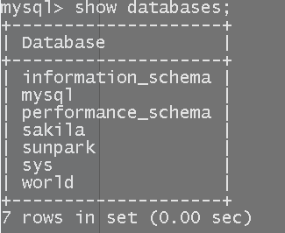

2. Write a query to use any predefined database from MySQL.



3. Write a query to display the description of any predefined database.

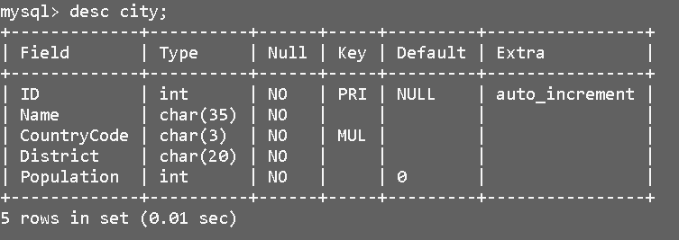

4. Write a query to display the rows from the predefined database.

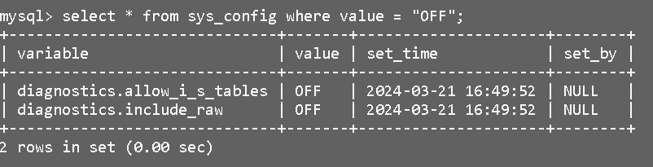

5. Write a query to create your user-defined database.

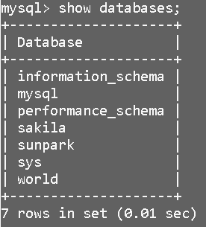

6. Write a query to use a user-defined database.



7. Write a query to create a student table with rno, name, and branch.

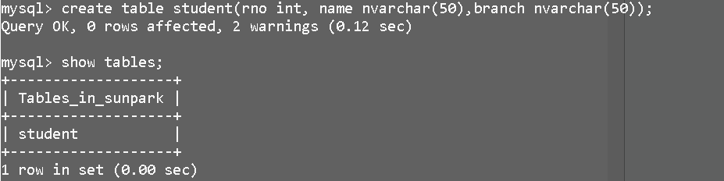

8. Write queries to insert a minimum of ten student data records into the student table.

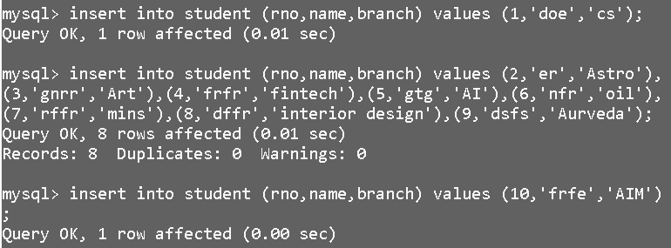

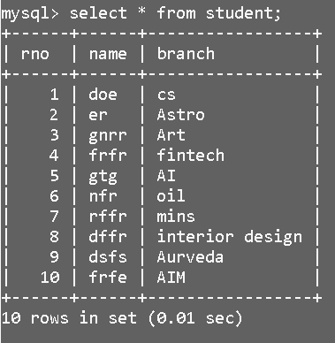

9. Write a query to add a new column college to the student table.

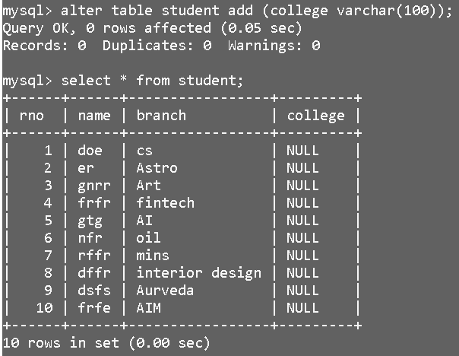

10. Write a query to update the college name as ‘Abc’ to all CSE branch students.

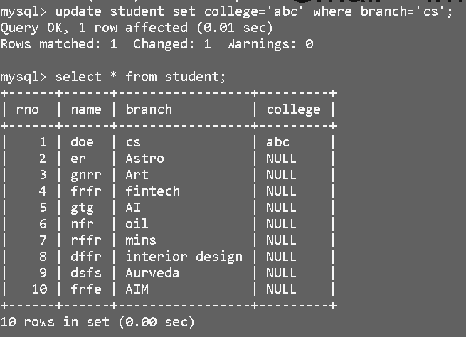

11. Write a query to update the college name as ‘Pqr’ to all ECE branch students.

# EC is not included but for branch “mins” to branch “pqr”.

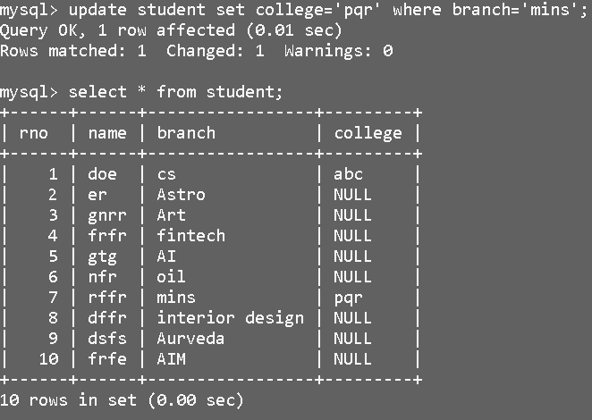

12. Write a query to delete a student whose rno=1;

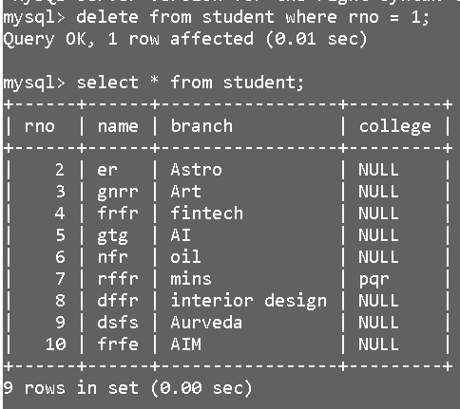

13. Write a query to delete students whose rno’s are 4 and 6.

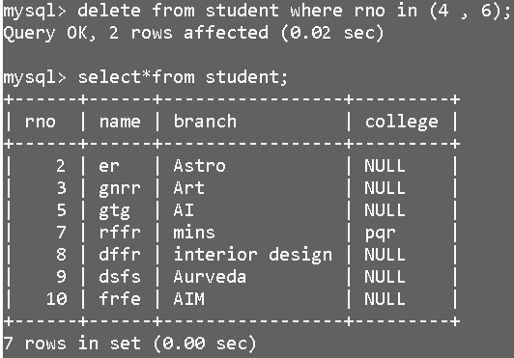

14. Write a query to perform the truncate operation on the student table.

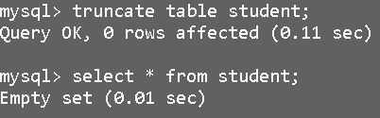

15. Write a query to perform a drop operation on the student table.

